

# TITLE- ENVOQUEST

# envoquest_logo

**PROJECT REPORT - OPEN SOURCE PROGRAMMING - ITE1008**

**BY-**

**AASHISH RAJ**

**18BIT0113**

SUBMITTED TO

**PROFESSOR SUMANGALI K**

1.0 ABSTRACT:

This project’s objective is to encourage people to do good to the environment. With this people can share their thoughts and come up with solutions to many of the small reasons of these problems.

In today’s fast moving world no one has time and no one likes to read long paragraphs regarding problems like these, that is why we created this project. This app of ours is meant to encourage people to use it more and more. Most people in today’s world likes to pictures of every small thing they do and upload it on their social networking sites because sometimes it’s easier to convey your message through a picture compared to that of some long texts. This website is meant for people to share their images of every thing happening with the environment, what have they done to contribute to solving these problems, what are the problems they have seen in their nearby areas, or if someone have found a new way to solve these problems. We can also write comments for the images uploaded by the others. This app is similar to **instagram** but its purpose is to make the environment better.

The reality is very few people care about these thing but everyone cares about themselves many wants to showoff themselves which sometimes makes people do things they don’t even care about. This app can even bring those people to do things like saving the environment.

## 2.0 INTRODUCTION:

This is a application where you can upload photos of problems you face in the environment and people connected to this will answer to your problems. Also you did any thing to make the environment better the take its picture and upload it and people will appreciate your work.

Here I have used HTML, CSS, Javascript, JQuery, Bootstrap, Ajax, AngularJs, **PHP and MySql** for making this website.

Here first you have to sign up and then create your account then you can login and this will direct you to the home page. Here you can see the posts of all users, can comment on the posts. In Sign up and login page I have applied validation using Bootstrap.

You can also upload your post by clicking on the add image button .

You can see posts of all users in a small format on clicking on this button .

You can also see posts uploaded by you in a small format on clicking on this button .

In the image uploading option you can only upload image extension files else error message will come.

## 3.0 FLOW OF PROJECT

### *3.1 Creating account*

STEP 1: Sign in

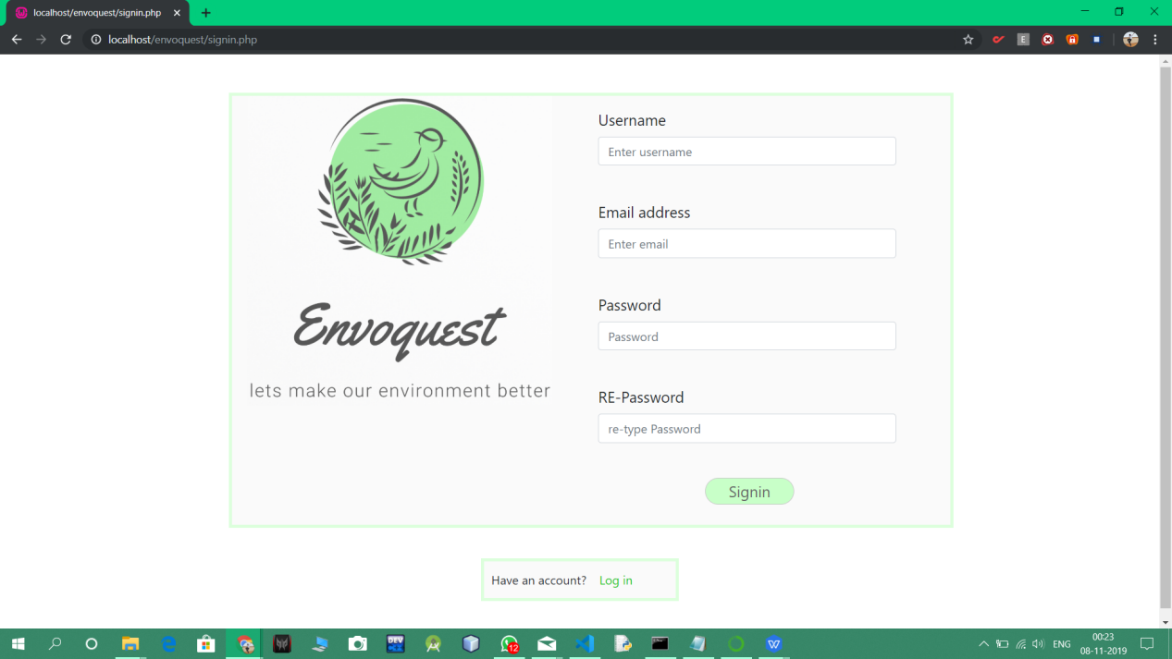

VALIDATION

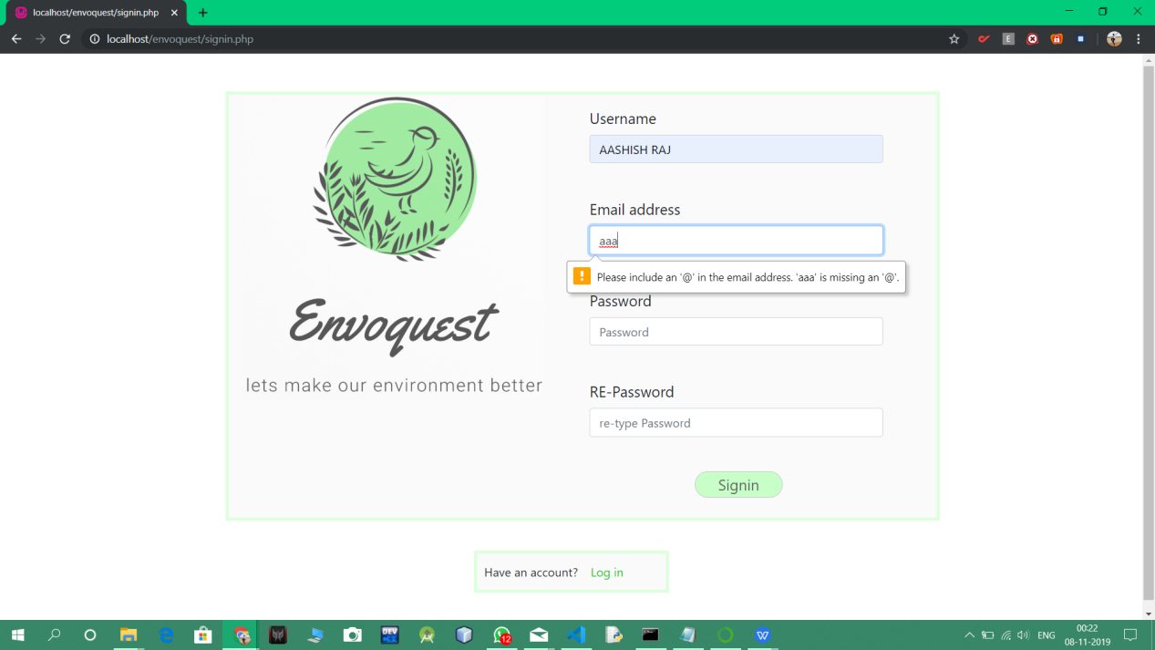

After Sign in Login page will appear

STEP 2: LOGIN

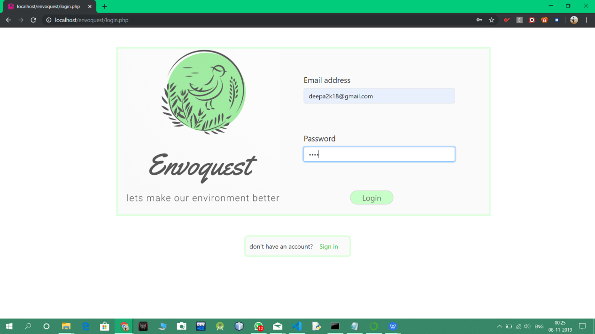

NOW HOME PAGE WILL APPEAR

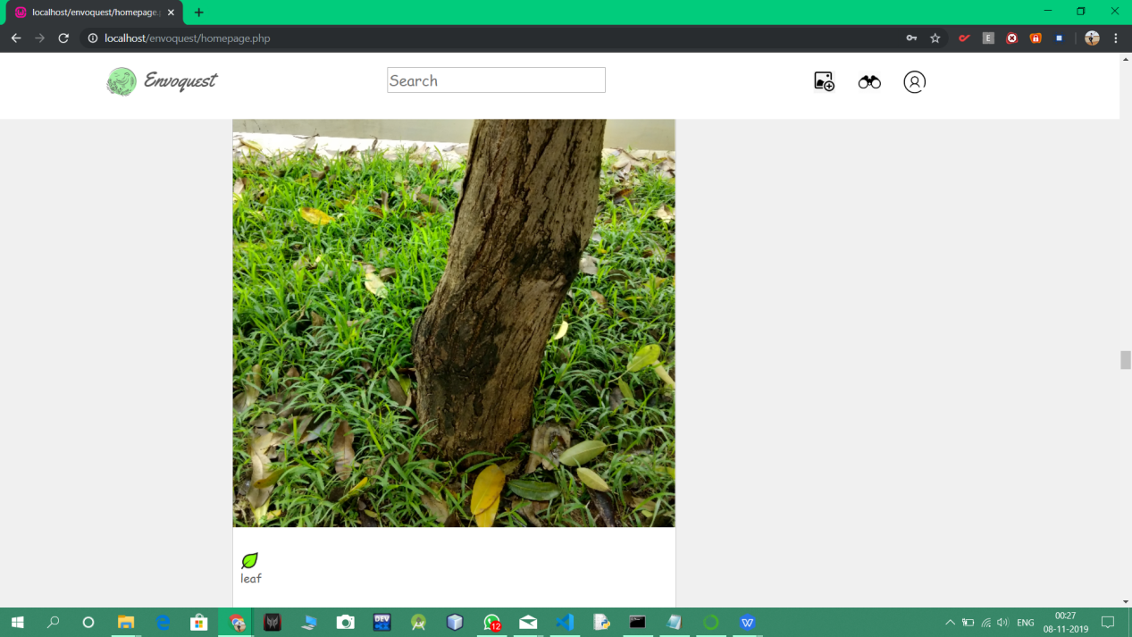

NOW YOU ARE READY TO USE IT.

### *3.2 uploading images*

upload your post by clicking on the add image button .

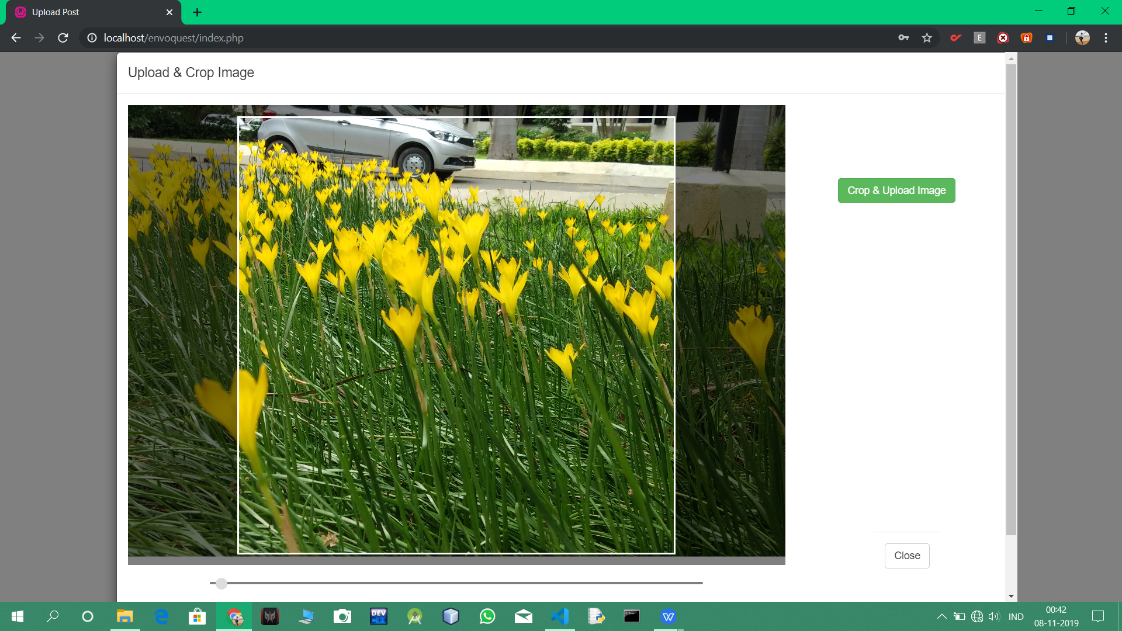

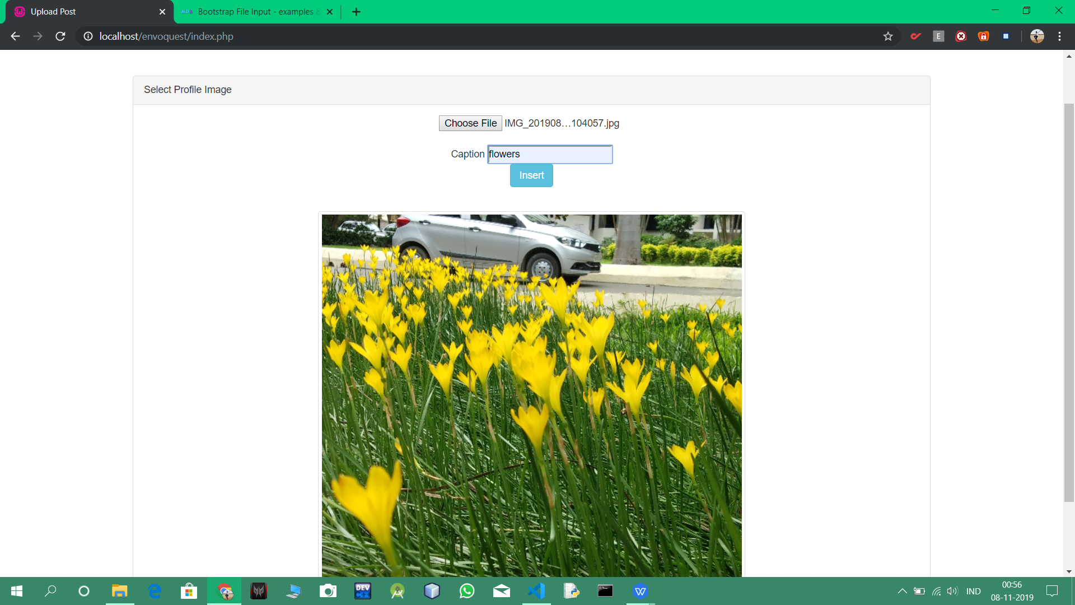

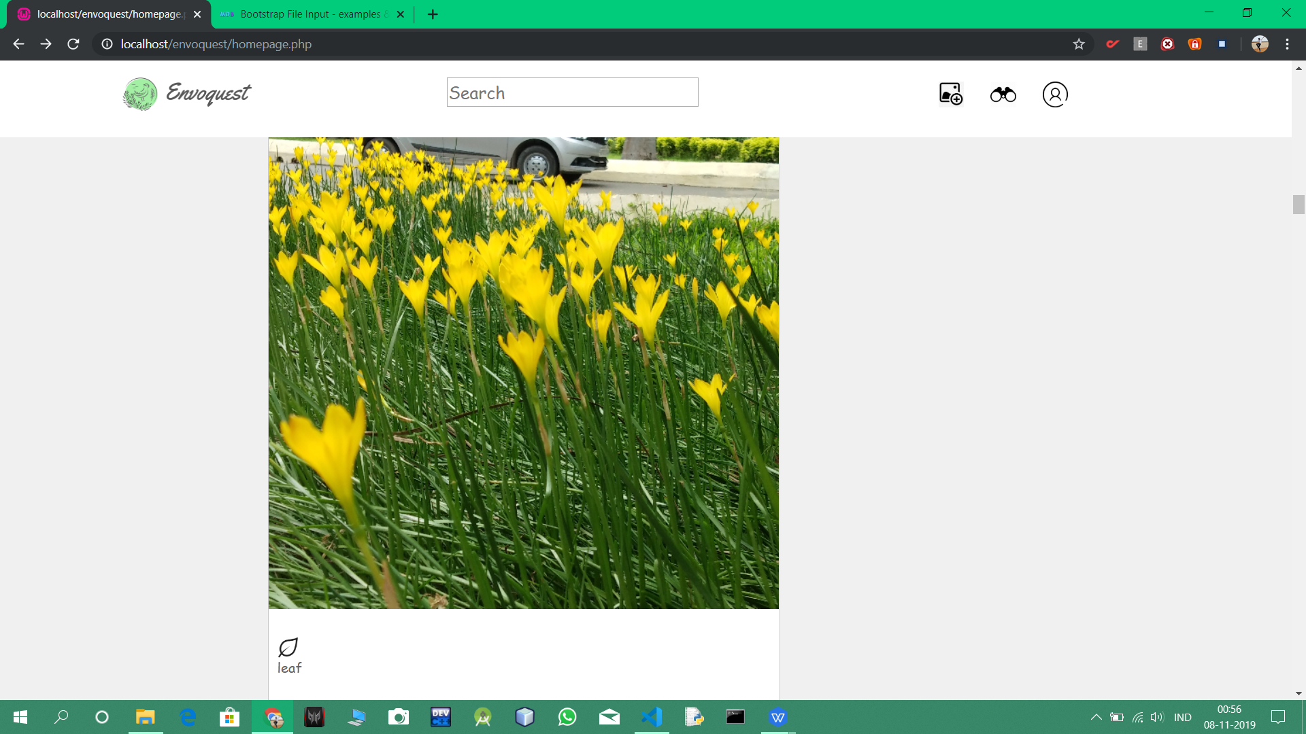

So its uploaded.

### *3.3 All posts*

clicking on this button  and you will see all posts

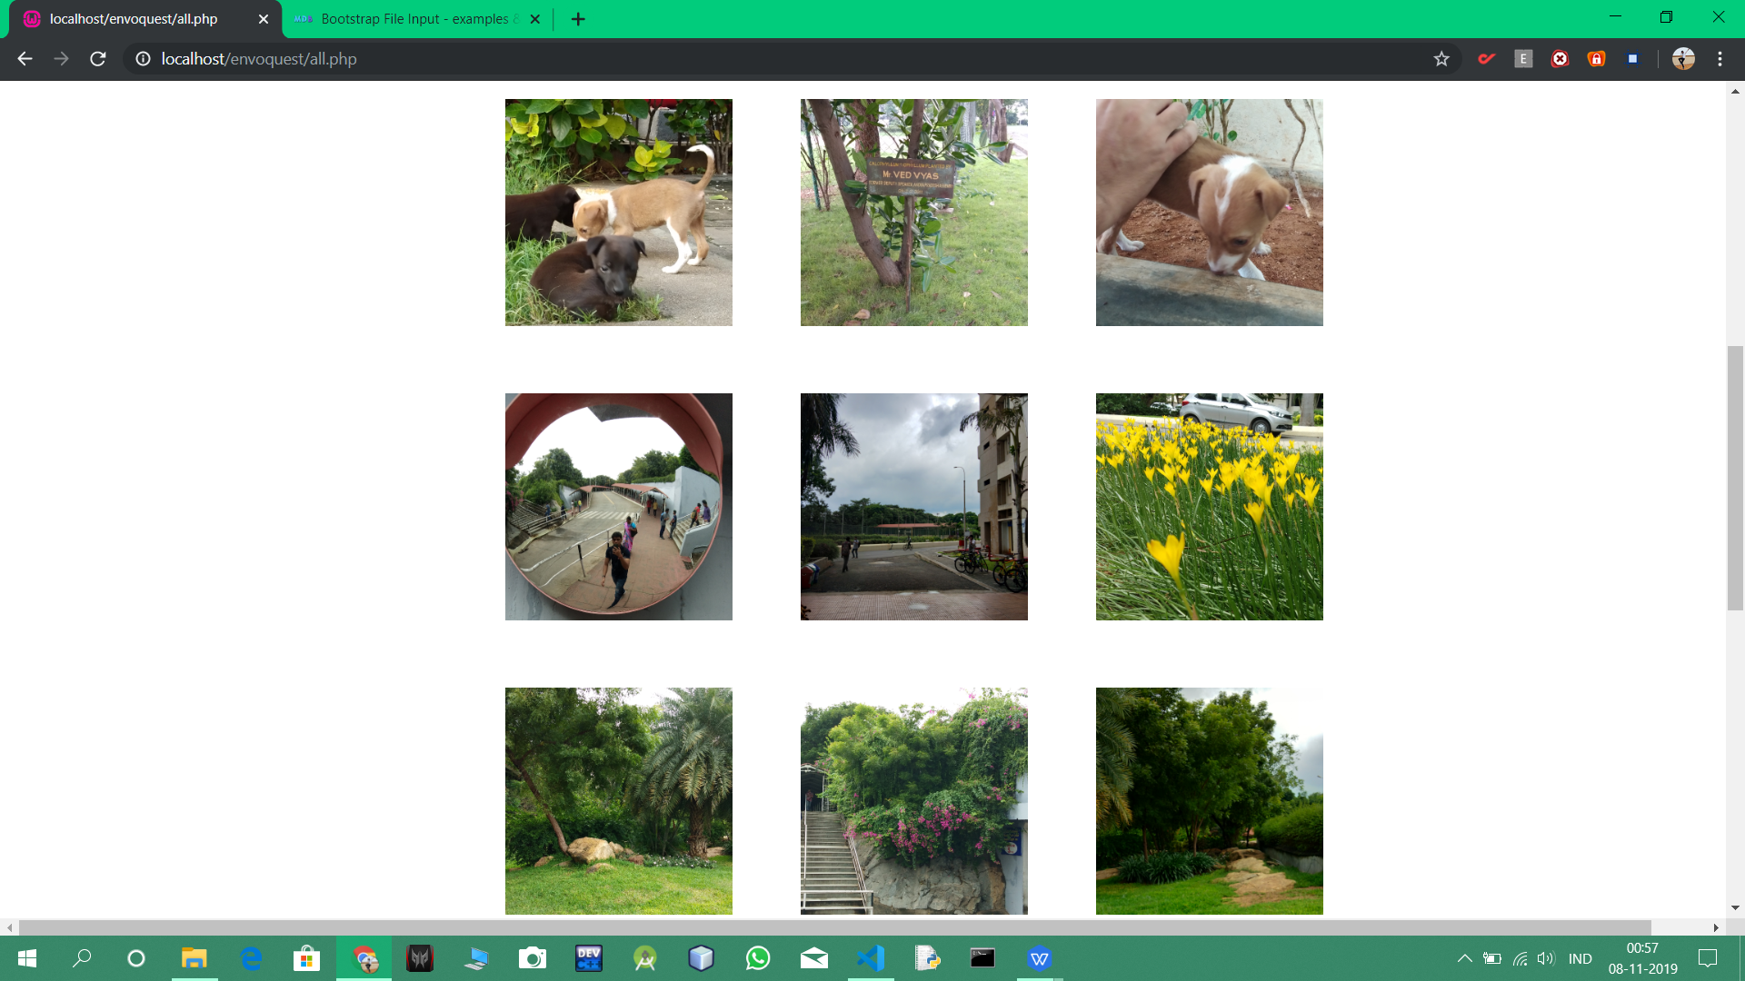

### *3.4 User*

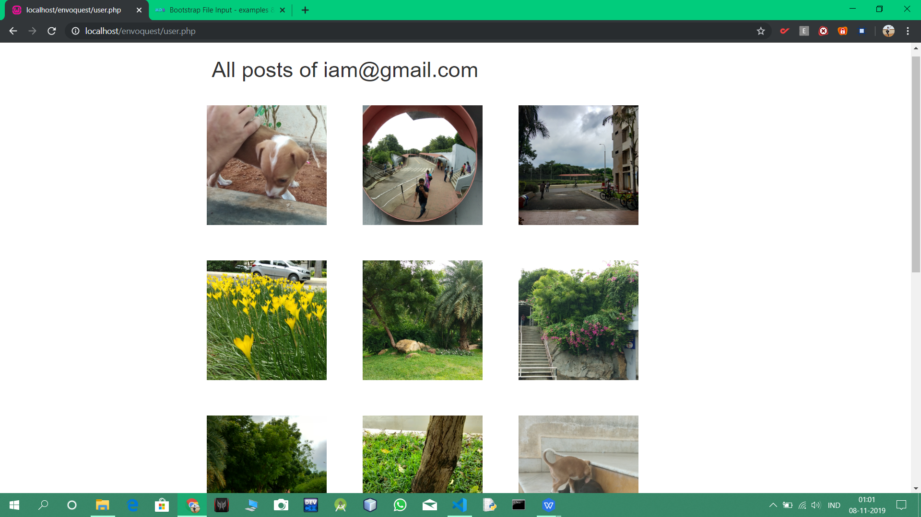

By clicking on submit button you can delete all posts uploaded by you.

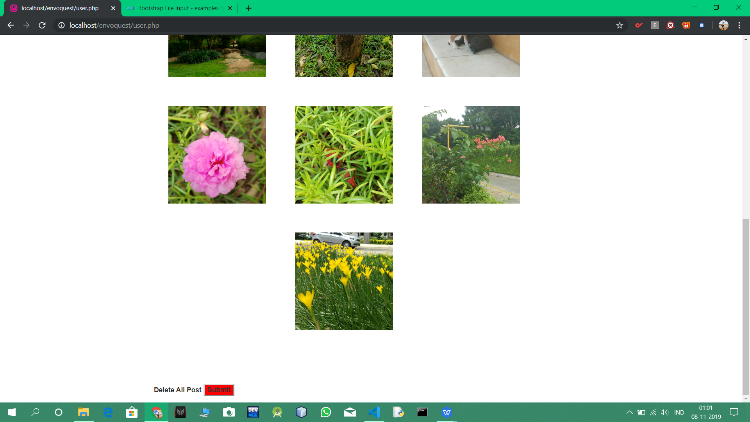

### *3.5 ADDING COMMENTS*

CLICK ON THE COMMENT BOX ENTER YOUR COMMENT AND CLICK POST.

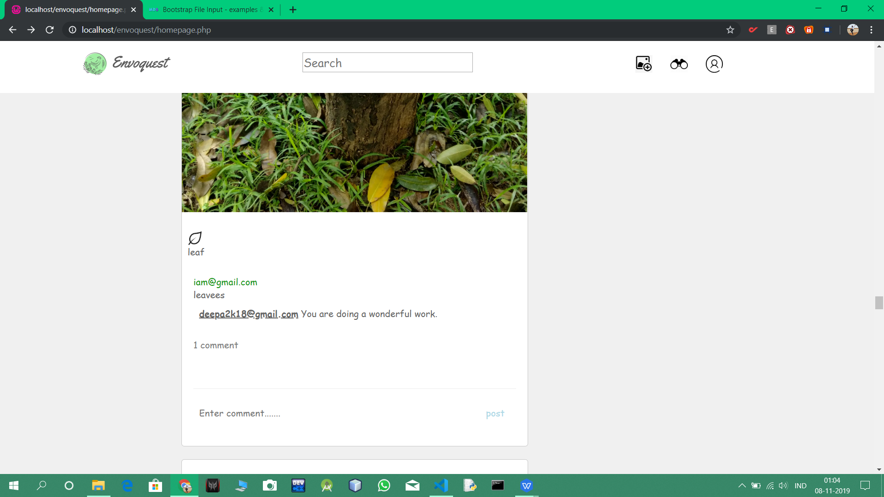

NOW COMMENT IS ADDED

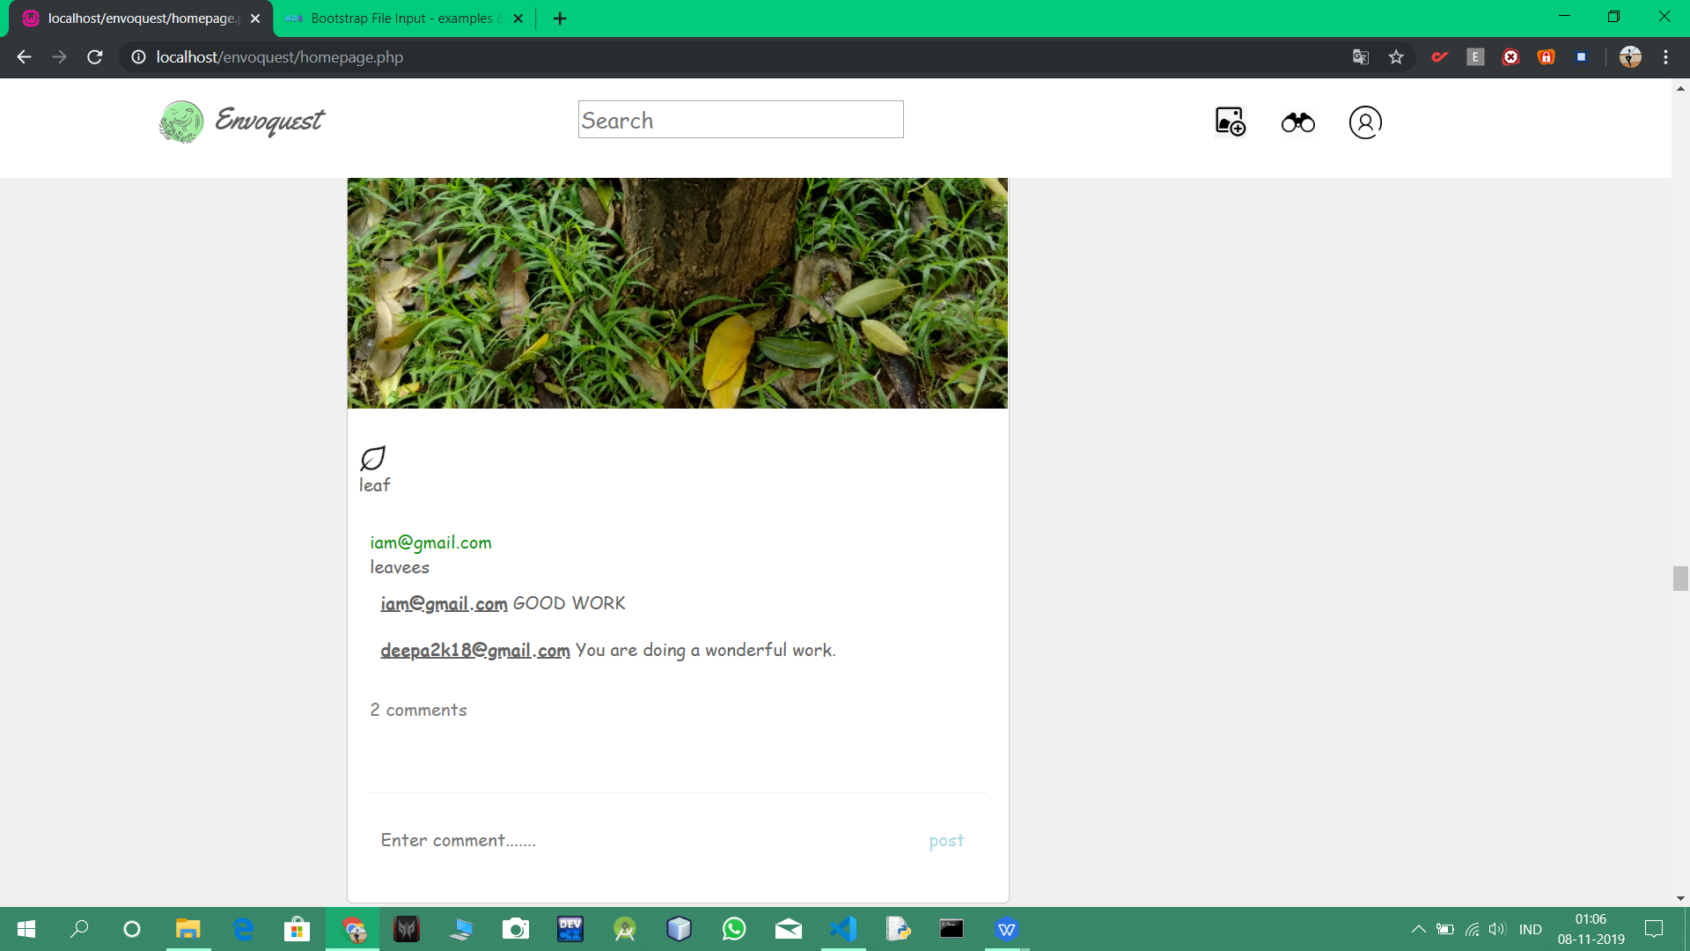

## 4.0 MYSQL DATABASE

### *4.1 PHOTOS TABLE*

### 

### *4.2 USERS TABLE*

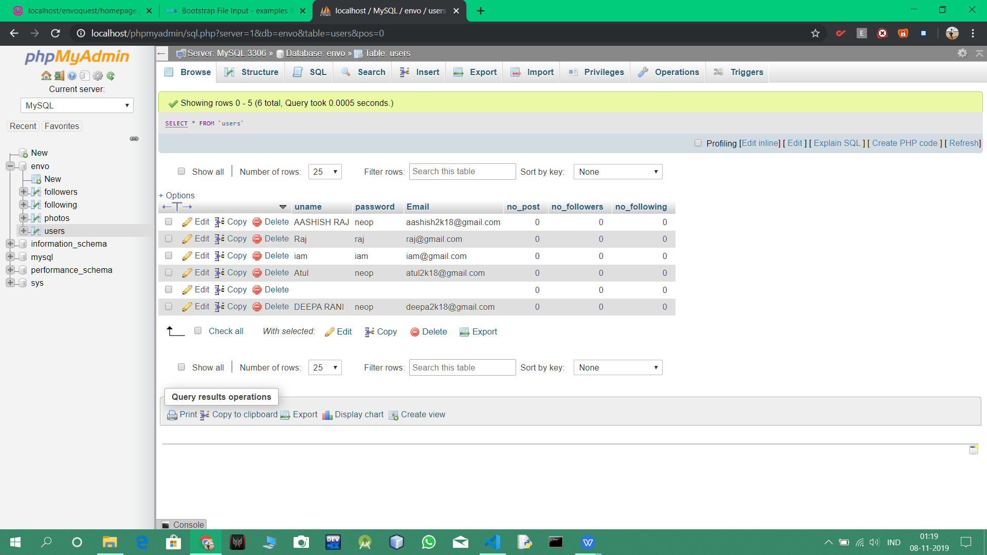

## **5.0 CODES**

### *5.1 Signin.php*

<html>

<head>

<link rel="stylesheet" href="https://stackpath.bootstrapcdn.com/bootstrap/4.3.1/css/bootstrap.min.css" integrity="sha384-ggOyR0iXCbMQv3Xipma34MD+dH/1fQ784/j6cY/iJTQUOhcWr7x9JvoRxT2MZw1T" crossorigin="anonymous">

<script src="https://code.jquery.com/jquery-3.3.1.slim.min.js" integrity="sha384-q8i/X+965DzO0rT7abK41JStQIAqVgRVzpbzo5smXKp4YfRvH+8abtTE1Pi6jizo" crossorigin="anonymous"></script>

<script src="https://cdnjs.cloudflare.com/ajax/libs/popper.js/1.14.7/umd/popper.min.js" integrity="sha384-UO2eT0CpHqdSJQ6hJty5KVphtPhzWj9WO1clHTMGa3JDZwrnQq4sF86dIHNDz0W1" crossorigin="anonymous"></script>

<script src="https://stackpath.bootstrapcdn.com/bootstrap/4.3.1/js/bootstrap.min.js" integrity="sha384-JjSmVgyd0p3pXB1rRibZUAYoIIy6OrQ6VrjIEaFf/nJGzIxFDsf4x0xIM+B07jRM" crossorigin="anonymous"></script>

<style type="text/css">

#box{   padding:10px;

    padding-right:200px;

    margin:auto;

    margin-top:100px;

    font-size:20px;

    width:600px;

    margin-left:450px;

    margin-top:-400px;

}

#signin{

    background-color:rgb(200,255,200);

    padding:2px 30px;

    border:1px solid rgb(200,200,200);

    border-radius:20px;

    margin-left:140px;

    color:rgb(100,100,100);

}

#logo{

    border-image: url(envoquest\_logo.png) 30 round;

}

#main{

    margin-left:300px;

    margin-right:300px;

    padding-left:100px;

    padding-right:100px;

    background-color:rgb(250,250,250);

    padding-left:20px;

    padding-right:100px;

    margin-right:100px;

    border:1px solid rgb(220,255,220);

    margin-top:20px;

    margin-right:200px;

    border-width: thick;

    margin-top:50px;

    margin-bottom:50px;

    margin-right:270px;

}

#log{

    border:1px solid rgb(220,255,220);

    background-color:rgb(250,250,250);

    padding:10px;

    margin-left: 630px;

    margin-right:630px;

    margin-top:-10px;

    margin-bottom:50px;

    border-width:thick;

}

#login{

    color:rgb(10,200,10);

    background-color:rgb(250,250,250);

    border:1px solid rgb(250,250,250);

    margin-left:10px;

}

</style>

</head>

<body>

<div id="main">

<div class="line"><img src="envoquest\_logo.png" id="logo" width="400"></div>

<form method="post" action="<?php echo $\_SERVER['PHP\_SELF']; ?>">

<div id="box" class="line">

   <div class="form-group">

    <label for="exampleInputEmail1">Username</label><br>

    <input type="text" name="name" placeholder="Enter username" class="form-control">

  </div>

<br>

  <div class="form-group">

    <label for="exampleInputEmail1">Email address</label>

    <input type="email" name="email" class="form-control" id="exampleInputEmail1" aria-describedby="emailHelp" placeholder="Enter email">

  </div>

<br>

  <div class="form-group">

    <label for="exampleInputPassword1">Password</label>

    <input type="password" name="pass" class="form-control" id="exampleInputPassword1" placeholder="Password">

  </div>

<br>

<div class="form-group">

    <label for="exampleInputPassword1">RE-Password</label>

    <input type="password" name="repass" class="form-control" id="exampleInputPassword1" placeholder="re-type Password">

  </div>

<br>

 <input type="submit" name="submit" value="Signin" id="signin">

</div>

</form>

</div>

<script >

function login(){

    window.open("login.php","\_self");

}

</script>

<div id="log">

Have an account?<button  onclick="login()" id="login"> Log in</button>

</div>

</body>

</html>

<?php

if(isset($\_POST['submit']))

{

    $name=$\_POST['name'];

    $pass=$\_POST['pass'];

    $repass=$\_POST['repass'];

    $email=$\_POST['email'];

    if(strcmp($repass,$pass)!=0)

    {

        echo '<script type="text/javascript">';

            echo 'alert("ERROR:password and retype password are not same")';

            echo '</script>';

    }

    else

    {

    $con=mysqli\_connect("localhost","root","");

    if(!$con){die('could not connectr'.mysqli\_error($con));}

    mysqli\_select\_db($con,"envo");

    $sql="INSERT INTO users(uname,email,password,no\_post,no\_followers,no\_following) values('$name','$email','$pass',0,0,0)";

    if(!mysqli\_query($con,$sql)){

    die('error'.mysqli\_error($con));

    }

    echo '<script type="text/javascript">';

            echo 'alert("1 record added")';

            echo '</script>';

            $link = "<script>window.open(\"login.php\",\"\_self\")</script>";

            echo $link;

    mysqli\_close($con);

    }

}

?>

### *5.2 login.php*

<html>

<head>

<link rel="stylesheet" href="https://stackpath.bootstrapcdn.com/bootstrap/4.3.1/css/bootstrap.min.css" integrity="sha384-ggOyR0iXCbMQv3Xipma34MD+dH/1fQ784/j6cY/iJTQUOhcWr7x9JvoRxT2MZw1T" crossorigin="anonymous">

<script src="https://code.jquery.com/jquery-3.3.1.slim.min.js" integrity="sha384-q8i/X+965DzO0rT7abK41JStQIAqVgRVzpbzo5smXKp4YfRvH+8abtTE1Pi6jizo" crossorigin="anonymous"></script>

<script src="https://cdnjs.cloudflare.com/ajax/libs/popper.js/1.14.7/umd/popper.min.js" integrity="sha384-UO2eT0CpHqdSJQ6hJty5KVphtPhzWj9WO1clHTMGa3JDZwrnQq4sF86dIHNDz0W1" crossorigin="anonymous"></script>

<script src="https://stackpath.bootstrapcdn.com/bootstrap/4.3.1/js/bootstrap.min.js" integrity="sha384-JjSmVgyd0p3pXB1rRibZUAYoIIy6OrQ6VrjIEaFf/nJGzIxFDsf4x0xIM+B07jRM" crossorigin="anonymous"></script>

<style type="text/css">

#box{

    padding:10px;

    padding-right:200px;

    margin:auto;

    margin-top:100px;

    font-size:20px;

    width:600px;

    margin-left:450px;

    margin-top:-350px;

}

#logo{

    border-image: url(envoquest\_logo.png) 30 round;

}

#login{

    background-color:rgb(200,255,200);

    padding:2px 30px;

    border:1px solid rgb(200,200,200);

    border-radius:20px;

    margin-left:120px;

    color:rgb(100,100,100);

}

#main{

    margin-left:300px;

    margin-right:300px;

    padding-left:100px;

    padding-right:100px;

    background-color:rgb(250,250,250);

    padding-left:20px;

    padding-right:100px;

    margin-right:100px;

    border:1px solid rgb(220,255,220);

    margin-top:20px;

    margin-right:200px;

    border-width: thick;

    margin-top:50px;

    margin-bottom:50px;

    margin-right:270px;

}

#sign{

    border:1px solid rgb(220,255,220);

    background-color:rgb(250,250,250);

    padding:10px;

    border-radius:10px;

    margin-left: 630px;

    margin-right:630px;

    margin-top:20px;

    margin-bottom:50px;

    border-width:thick;

}

#signin{

    color:rgb(10,200,10);

    background-color:rgb(250,250,250);

    border:1px solid rgb(250,250,250);

    margin-left:10px;

}

</style>

<scipt >

</head>

<body>

<div id="main">

<div class="line"><img src="envoquest\_logo.png" id="logo" width="400"></div>

<form method="post" action="<?php echo $\_SERVER['PHP\_SELF']; ?>" enctype="multipart/form-data">

<div id="box" class="line">

  <div class="form-group">

    <label for="exampleInputEmail1">Email address</label>

    <input type="email" name="email" class="form-control" id="exampleInputEmail1" aria-describedby="emailHelp" placeholder="Enter Email">

  </div>

<br><br>

  <div class="form-group">

    <label for="exampleInputPassword1">Password</label>

    <input type="password" name="pass" class="form-control" id="exampleInputPassword1" placeholder="Password">

  </div>

<br><br>

 <input type="submit" name="submit" value="Login" id="login">

</div>

</form>

</div>

<script >

    function signin(){

        window.open("signin.php","\_self");

    }

    </script>

<div id="sign">

    don't have an account?<button  onclick="signin()" id="signin"> Sign in</button>

    </div>

</body>

</html>

<?php

if(isset($\_POST['submit']))

{

    $email=$\_POST['email'];

    $pass=$\_POST['pass'];

    if($email==""){

        echo '<script type="text/javascript">';

        echo 'alert("enter the email")';

        echo '</script>';

    }

    else{

    session\_start();

    $con=mysqli\_connect("localhost","root","");

    if(!$con){die('could not connectr'.mysqli\_error($con));}

    mysqli\_select\_db($con,"envo");

    $query="SELECT \* FROM users where email=\"$email\"";

    $result=mysqli\_query($con,$query);

    echo $query;

    $r=0;

    while($row=mysqli\_fetch\_array($result))

    {   $r=1;

        $spass=$row['password'];

        if(strcmp($spass,$pass)==0){

            $\_SESSION['email']=$email;

            $\_SESSION['name']=$row['uname'];

            $link = "<script>window.open(\"homepage.php\",\"\_self\")</script>";

            echo $link;

        }

        else{

            echo '<script type="text/javascript">';

            echo 'alert("password not exists".$result.$spass)';

            echo '</script>';

            }

    }

    if($r==0){

        echo '<script type="text/javascript">';

            echo 'alert("user do not exists please signin".$result.$spass)';

            echo '</script>';

    }

    mysqli\_close($con);

    }

}

?>

*5.3 homepage.php (only php part)*

<?php

   session\_start();

?>

<b>hello  </b><b><?=$\_SESSION['email'];?>

         <table  >

              <tr>

                   <th>Image</th>

              </tr>

         <?php

         $con = mysqli\_connect("localhost", "root", "");

             if(!$con)

             {die('could not connectr'.mysqli\_error($con));}

             mysqli\_select\_db($con,"envo");

         $email=$\_SESSION['email'];

         $query = "SELECT \* FROM photos ORDER BY udate DESC";

         $result = mysqli\_query($con, $query);

         while($row = mysqli\_fetch\_array($result))

         {  $i=$row['comments'];

            $j=$i;

            $l=$row['likes'];

              echo '

                   <tr >

                        <td>

                        <br>

                        <div style="padding-top:30px;padding-bottom:0px;

              border:1px solid rgb(200,200,200);

              border-radius:5px; color:rgb(100,100,100);margin-right:460px; background-color:rgb(255,255,255);">

                                <hr>

                              <img id=myImg height=600px width=600px src="http://localhost/envoquest/'.$row['photo'].'" class="img-thumnail" />

                              <br><br>

                              <div style="padding:10px;" class="likes">

                              <img id=myImg height=25px width=25px src="http://localhost/envoquest/leaf\_n" class="leaf\_n">

                              <br>

                                '.$l.' leaf

                              </div>

                                <div style="padding:20px;">

                              <div style="color:rgb(10,150,10)"> '.$row['email']."</div>".$row['caption'].'<br>

                              ';

                              while($i>0){

                                echo

                                  '<div style="padding:10px;">'.$row['comment'.$i].'</div>';

                                  $i=$i-1;

                              }

                              if($j==1){

                                echo

                                '

                                <br><div class="comments" style="color:grey"> '.$j.' comment</div><br> ';}

                              if($j>1){

                              echo

                              '

                              <br><div class="comments" style="color:grey"> '.$j.' comments</div><br> ';}

                             echo

                              '

                              <br>

                                <hr>

                              <form method="post" enctype="multipart/form-data">

                              <input hidden name="photo" value="'.$row['photo'].'">

                                 <input type="text" name="com" id="com" size="45%" placeholder="Enter comment......." style="border:none; padding:10px;">

                                 <input type="submit" name="post" value="post" style="color:lightblue; padding:10px;border:none;background-color:white;" >

                                 </form>

                                </div>

                              ';

                              echo

                              '

                              </div>

                        </td>

                   </tr>

                   <br>

              '

              ;

         }

         if(isset($\_POST['post'])){

                $photo=$\_POST['photo'];

                $query="SELECT \* FROM photos where photo=\"$photo\"";

                $result=mysqli\_query($con,$query);

                while($row=mysqli\_fetch\_array($result))

                {   $com='<b><u>'.$\_SESSION['email'].'</u></b>&nbsp'.$\_POST['com'];

                    $i=$row["comments"];

                    $i=$i+1;

                    $query="ALTER TABLE photos ADD COLUMN comment$i VARCHAR(100)";

                    if(!mysqli\_query($con,$query))

                        echo "error".mysqli\_error();

                    $query="UPDATE photos SET comments=$i WHERE photo=\"$photo\"";

                    if(!mysqli\_query($con,$query))

                        echo "error".mysqli\_error();

                    $query="UPDATE photos SET comment$i=\"$com\" WHERE photo=\"$photo\"";

                    if(!mysqli\_query($con,$query))

                        echo "error".mysqli\_error();

                        $link = "<script>window.open(\"homepage.php\",\"\_self\")</script>";

                        echo $link;

                    break;

                }

            /\*$i=0;

            $query="ALTER TABLE photos

            ADD COLUMN comment1 VARCHAR(100);";

            $query="UPDATE photos

            SET comments=$i

            WHERE

            email = $email;";

            if(mysqli\_query($con,$query))

            {

                 echo '<script>alert("Image Inserted into Database")</script>';

            }

            \*/

         }

         ?>

## 6.0 OVERALL DESCRIPTION

Well, this project is made for wellness and awareness of people about the environment and how to make it better by showing them through photos and asking people if they are facing environmental problems.